MSS System Source Code and Database Deployment Instruction

Contents

1. DB Set Up: 1

1.1 SQL Table Construction Query 3

1.2 Additional Note: 5

2. PHP Files Deployment 5

# DB Set Up:

1. Picked a webhosting website of your choice. Alternatively you can use the webhosting website with login details as below:

* Access: [www.000webhost.com](http://www.000webhost.com)
* Username: <your username>
* Password: <your password>

1. Navigate to the following directory , select Website msst4, on the left menu bar, select tool->Database Manager , Create a new DB of your own. Select DB name: <your db name>🡪 Manage 🡪 phpMyAdmin.
2. Select DB name: <your db name>, choose to run the Query Code in next section
3. Note down the DB Name, DB User, and DB Password, change it in the DbConnect.php file.
4. Refer figure 1 to 3 for illustration.

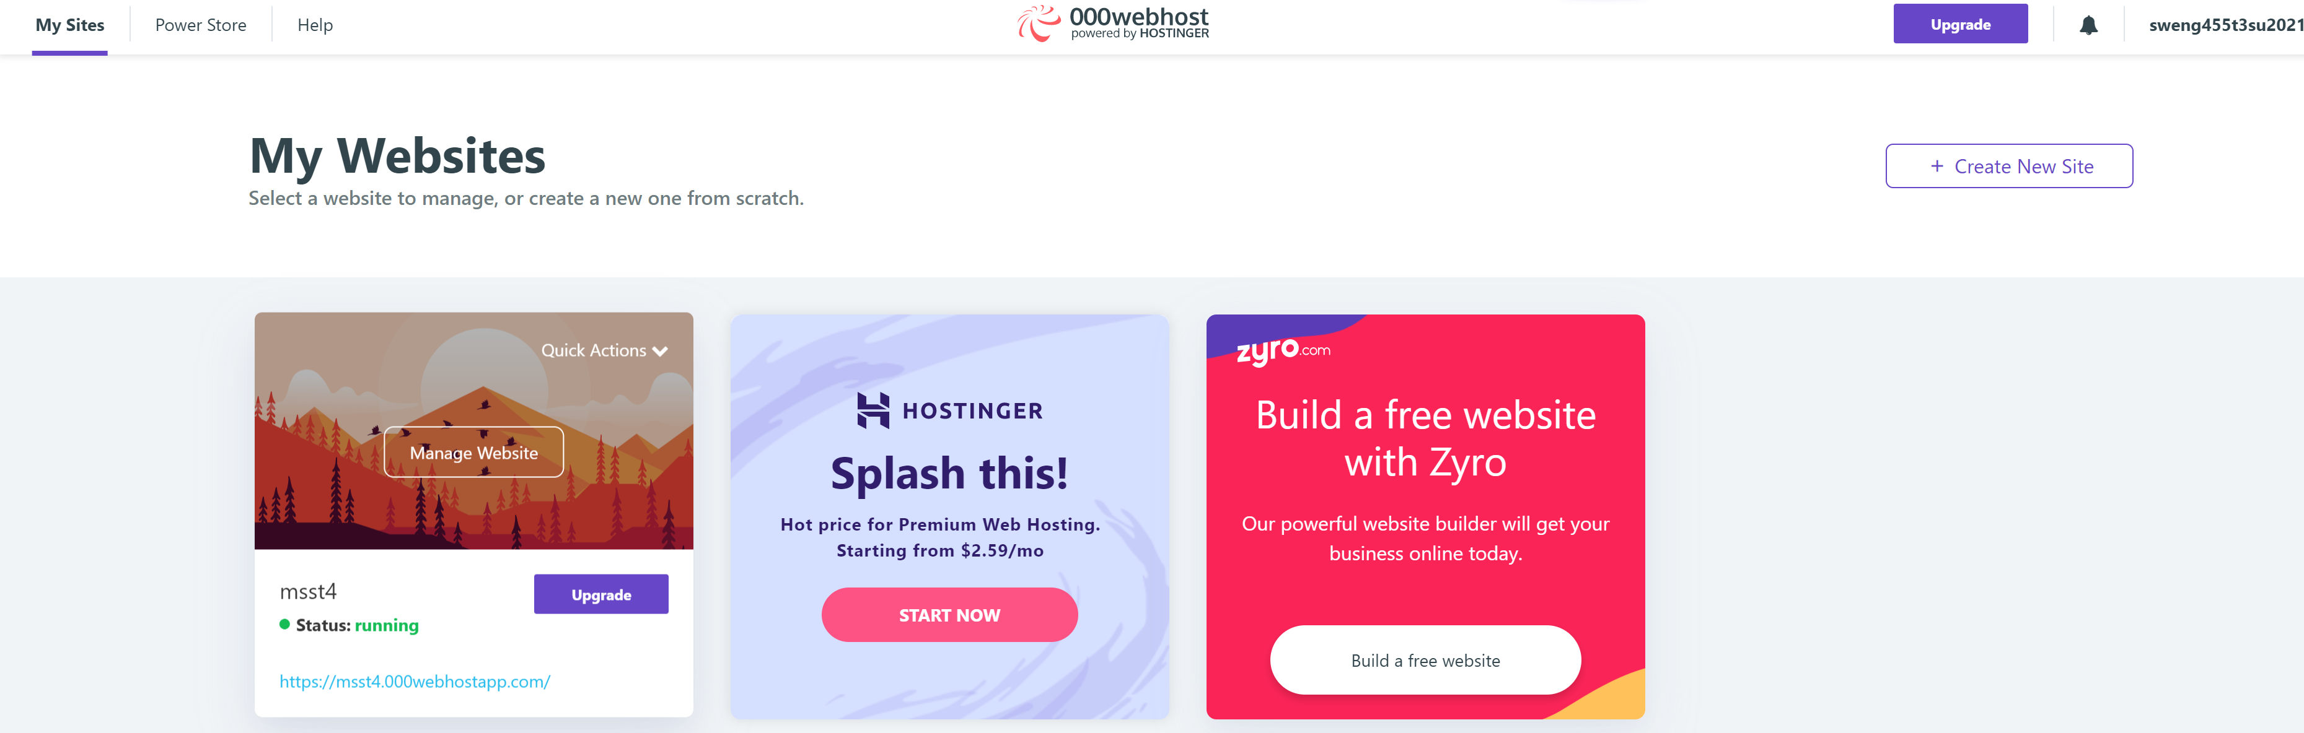

Figure : Front View of Webhost.com, click Manage Website

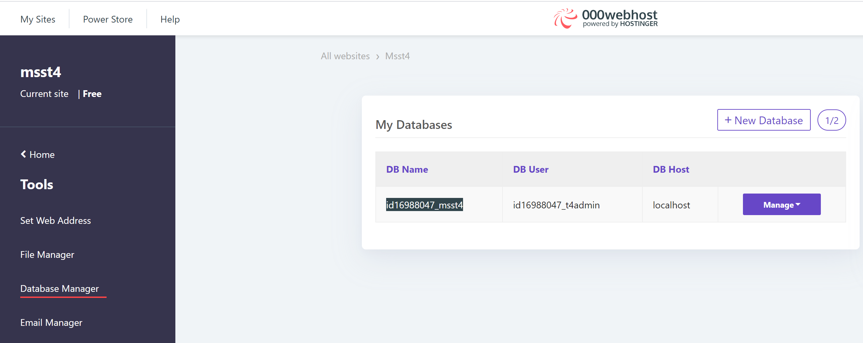

Figure : Database Manager -> click manage -> phpMyAdmin

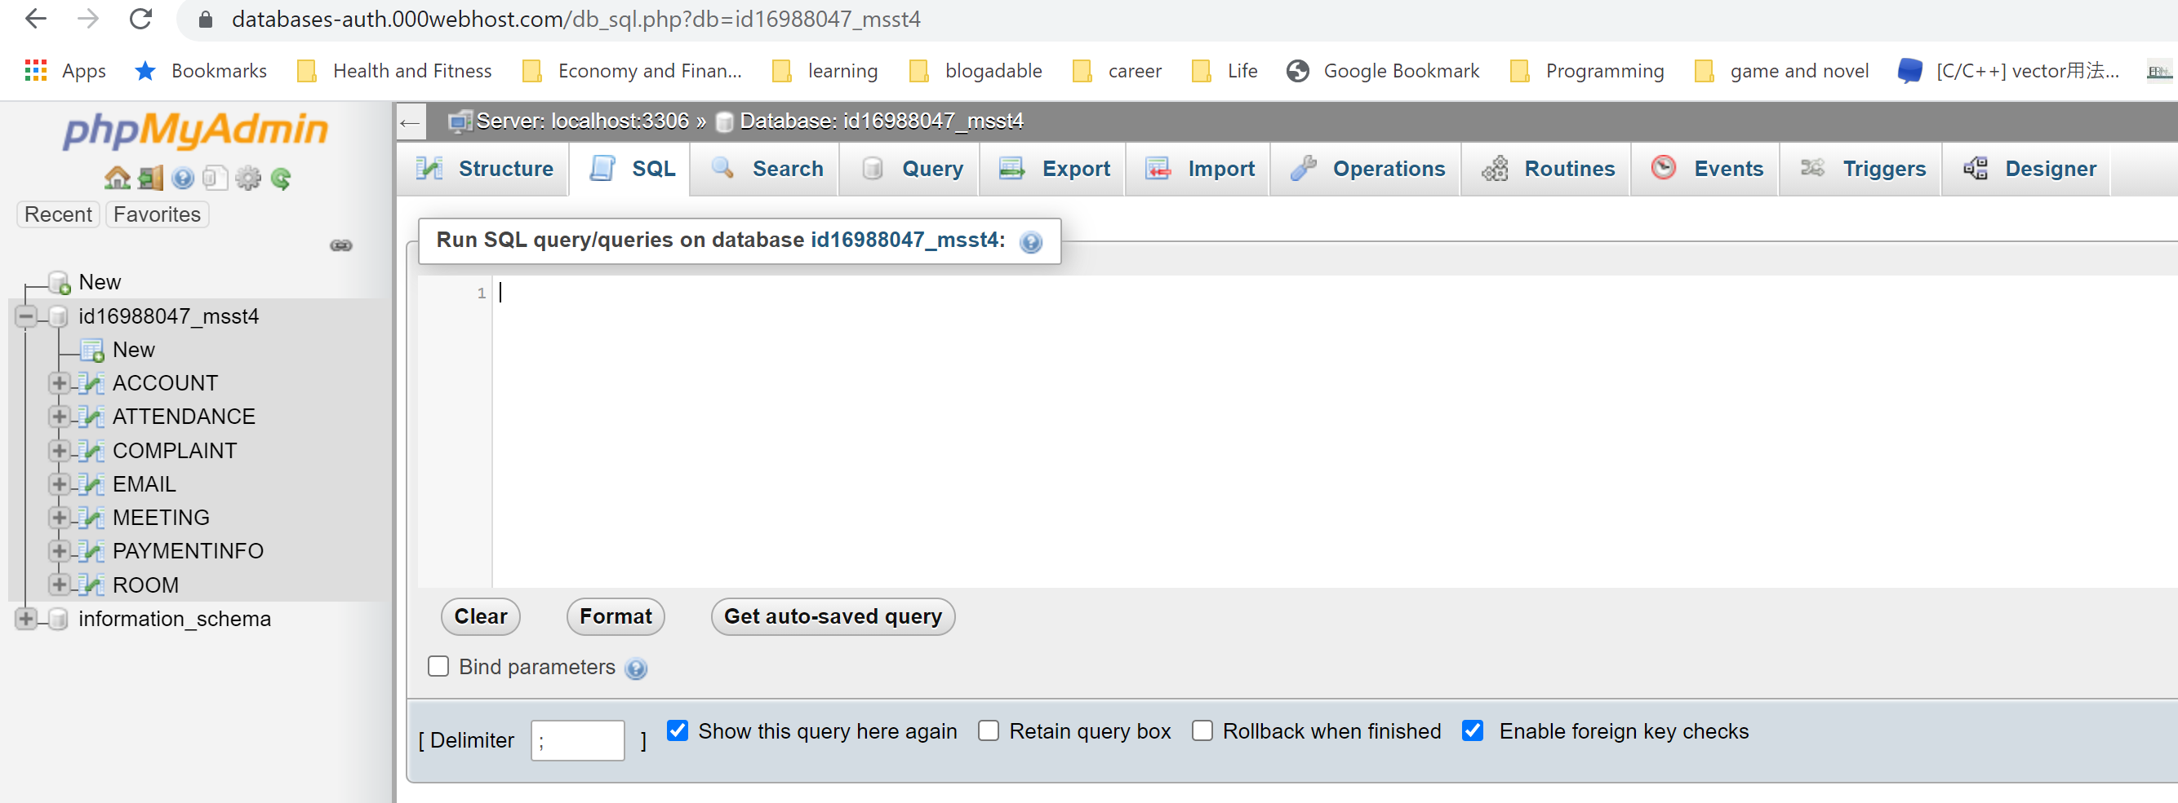

Figure : Run the SL Construction Code in section 1.1

## 1.1 SQL Table Construction Query

CREATE TABLE EMAIL(

COMPANY_EMAIL VARCHAR(50)

);

INSERT INTO EMAIL(COMPANY_EMAIL) values ("testing@yahoo.com");

INSERT INTO EMAIL(COMPANY_EMAIL) values ("testing@gmail.com");

INSERT INTO EMAIL(COMPANY_EMAIL) values ("testing@PennStateSoft.com");

CREATE TABLE ACCOUNT

(

USERNAME VARCHAR(25) NOT NULL PRIMARY KEY,

PASSWORD VARCHAR(60) NOT NULL,

FULLNAME VARCHAR(50),

CONTACT VARCHAR(20),

JOBTITLE VARCHAR(50),

BIOGRAPHY VARCHAR(250),

IS_ADMIN BOOLEAN,

COMPANY_EMAIL VARCHAR(50)

);

CREATE TABLE MEETING

(

MEETING_ID INT NOT NULL AUTO_INCREMENT PRIMARY KEY,

MEETING_NAME VARCHAR(25) NOT NULL,

START_TIME DATETIME,

END_TIME DATETIME,

ORGANIZER VARCHAR(25),

ROOM_ID CHAR(5)

);

CREATE TABLE ATTENDANCE

(

MEETING_ID INT NOT NULL,

ATTENDEE VARCHAR(25)

);

CREATE TABLE PAYMENTINFO

(

CARD_ID INT NOT NULL AUTO_INCREMENT PRIMARY KEY,

CC_NUMBER LONGTEXT NOT NULL,

CVV LONGTEXT NOT NULL,

CARD_OWNER VARCHAR(50),

EXP_DATE VARCHAR(10),

USERNAME VARCHAR(25)

);

CREATE TABLE ROOM

(

ROOM_ID CHAR(5) NOT NULL PRIMARY KEY,

IS_SPECIAL BOOLEAN,

CAPACITY INT,

LOCATION VARCHAR(50)

);

CREATE TABLE COMPLAINT

(

COMPLAINT_ID INT NOT NULL AUTO_INCREMENT PRIMARY KEY,

SUBJECT VARCHAR(50),

DESCRIPTION VARCHAR(250),

EMAIL VARCHAR(25),

IS_RESOLVED BOOLEAN

);

## Additional Note:

Built directly in DB GUI:

* Foreign Key constraints

# PHP Files Deployment

1. Using the same webhosting website for database set up. Navigate to the following directory , select Website msst4, on the left menu bar, select tool->File Manager, click upload file.
2. Copy the php files and css files under the main source code folder into the public_html directory. Copy the controller and object files inside the private folder to the private folder directory. (note the name of the folder need to be private and put it under the public_html folder).
3. Refer figure 4 and 5 for illustration.

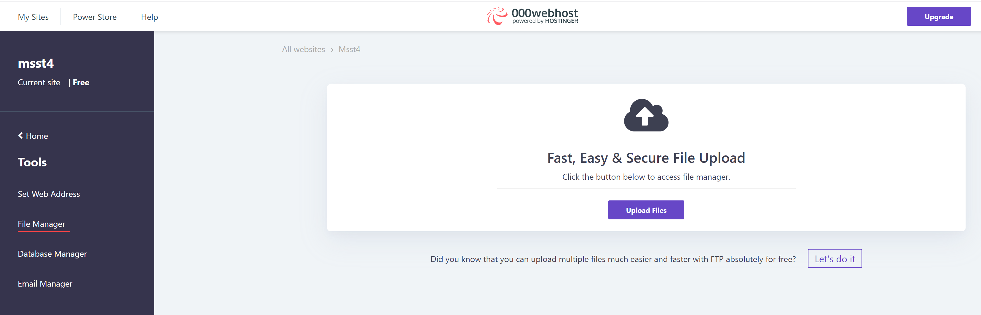

Figure : Select the Upload Files button to upload file

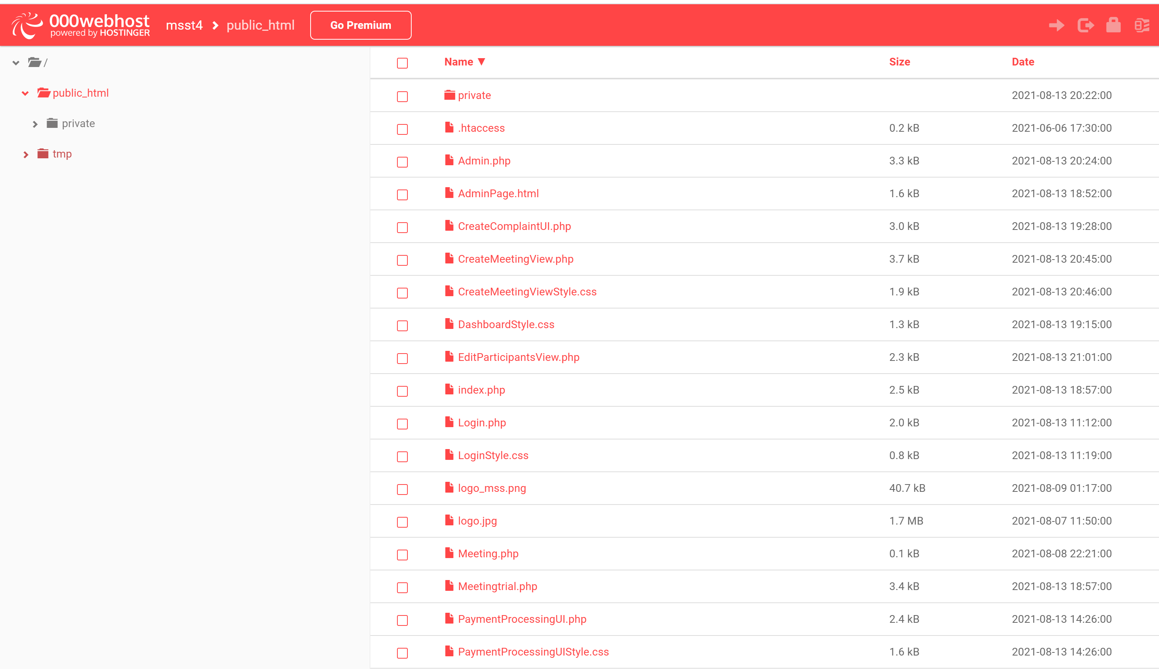

Figure : Example folder structure